**DermNet Project Report**

Building a deep learning model that classifies skin images with samples of 8 common skin pathologies and carcinoma.

Classify the diseases using best deep learning architecture for classification

Details of 1St part of the project 3

Batch Size=30 . Epoch= 17 , Samples= 2400

Convolution Layer:5 Number of Classes=7 Maxpooling layer=2

Kernel size =3*3 dense=512 dropout=0.5

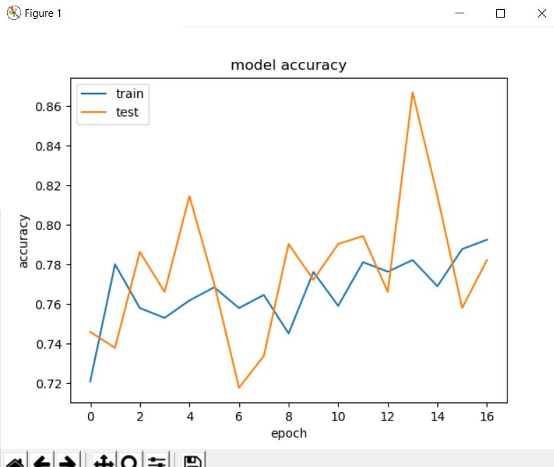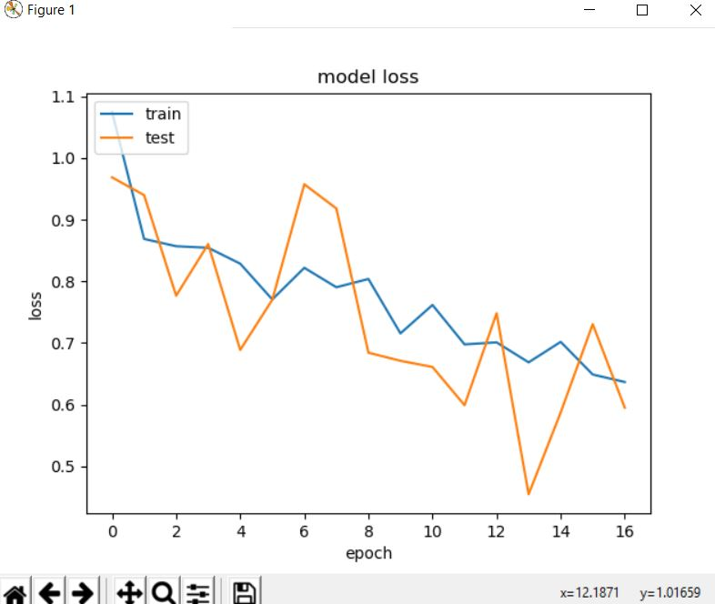

Second part Transfer Learning ResNet50

Use transfer learning on ResNet, GoogleNet to retrain some part of the network

Batch Size=2 . Epoch= 10 , Samples= 2423

Filter size:128,128,3 Convolution Layer:5

Number of Classes=7 Maxpooling layer=2

Image width=224 Image height=224

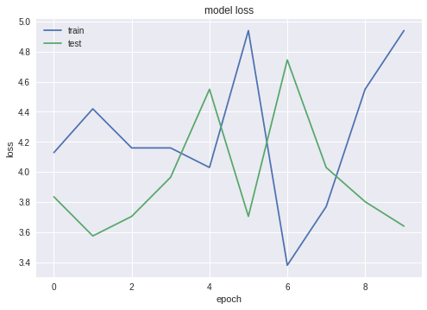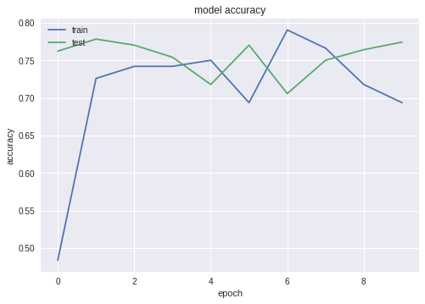

Second part Transfer Learning InceptionV3

Use transfer learning on ResNet, GoogleNet to retrain some part of the network

Batch Size=20 . Epoch= 20 , Samples= 2423

Convolution Layer:all

Number of Classes=7 Maxpooling layer=all

Image width=224 Image height=224

